Mississippi State Federation of Colored Women’s Clubs, Incorporated and Youth Affiliates

“Lifting As We Climb”

Official Convention Call
113TH Annual Convention-120th Anniversary
November 17-19,2023
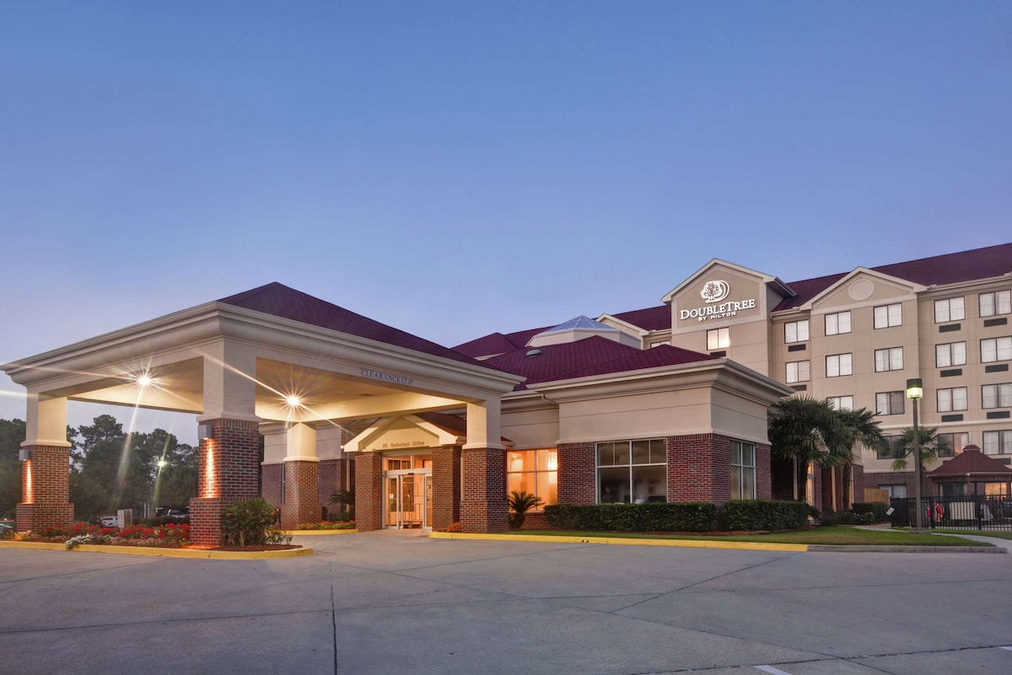
Convention Host MSFCWC 6th District
Double Tree Hotel Convention Site
10 Gateway Drive Hattiesburg, MS 39402

Mississippi State Federation of Colored Women’s Clubs, Inc. and Youth Affiliates
Mrs. Mary J. Collier, President
colliermaryj@yahoo.com
601-750-8621
STATE OFFICERS
Mary Collier, President Ernestine Bridges, Vice Pres. Leonia Dorsey, 2rd Vice Pres
Ashley Gilyard, 3rd Vice Pres.
Chris Watkins, Secretary
Irene Booker, Assistant Sect. Delores Hopkins, Treasurer Edna White, Financial Sect.
Monocia Connors, Chaplain
Theresa Hence, Statistician Donna Williams, Auditor
Terryce Walker, Historian
Barbara Tillman, Pianist
Gwendolyn Chess, Parlimentarian
Minnie Vaughn, Youth Supervisor
Celester Hall, Youth
Supervisor
Carol Cooper, Exec. Sect.

DISTRICT PRESIDENTS
District I, Lila Wade
District II, Vacant
District III, Jo Thompson
District IV, Delores Hopkins
District V, Lynda Taylor
District VI, Edna White

PAST LIVING PRESIDENTS
Helen Moore
Barbara B. Quinn
Lela Rayborn
Edna White
Lynda Taylor Carol Cooper, Immediate Past President

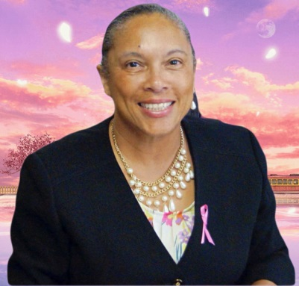
September 03, 2023

Greetings:

As the 35th President of Mississippi State Federation of Colored Women’s Clubs, Inc. and Youth Affiliates, it is my honor to welcome State Officers, Past State Presidents, District Presidents, Federated Sisters, Young Adults, Youth, friends and supporters to our 113th Annual Convention and the 118th Anniversary of MSFCWC.

We are blessed to be able to once again meet face to face to reflect on our past achievements and to celebrate our accomplishments. It is my sincere desire that this Convention will be a success and the business of MSFCWC will be handled with love and sisterhood. As we focus on our theme: “Utilizing Our Resources to Sustain our Legacy of Service, Scholarship, Sacrifice and Sisterhood,” we will continue in our efforts to secure better economic, moral, religious and social welfare within our communities, our state and the nation. Our motto “Lifting as We Climb” compels us to be a beacon of service and light for our communities.

We extend heartfelt gratitude to the members of the 6th District who have worked faithfully for us to have an enjoyable and informative Convention.
I encourage you to grasp every nugget of information that you can and share with your club sisters so that we can continue the legacy that our fore sisters so boldly exemplified.

Blessings,
Mary J. Collier

Mississippi State Federation of Colored Women’s Clubs, Incorporated and Youth Affiliates

2023 Convention at a Glance

Friday, November 17, 2023

12:00 PM – 5:00 PM |  | Registration
12:30 PM – 2:30 PM |  | Executive Board Meeting
3:00 PM – 5:00 PM |  | First Plenary Session
5:00 PM – 5:30 PM  5:30PM – 6:15 PM |  | Committee Meetings  Choir Rehearsal
7:00 PM  Saturday, November 18, 2023 |  | Welcome Program
8:00 AM – 9:00 AM |  | Registration
9:00 PM – 10:30 AM |  | Second Plenary, Opening Ceremony  Memorial Ceremony
10:45 AM – 11:45 AM |  | Workshop
12:00 PM – 1:30 PM |  | President’s Luncheon
1:45 PM – 3:45 PM |  | Third Plenary Session
4:00 PM –5:15 PM |  | Youth Competition
7:00 PM – 9:00 PM |  | Awards Banquet
7:00 PM  Sunday, November 19, 2023 |  | Youth Night
7:30 AM – 9:30 AM |  | Prayer Breakfast – (Youth and Adults)
9:45 AM |  | Fourth Plenary Session

Closing of Convention 2023

General Information

DOUBLE TREE BY Hilton
10 Gateway Drive
Hattiesburg, MS 39402
Room Rate: $129 per night plus tax
Please call Hotel direct at 601-296-0302 and reference the code FCM to reserve rooms. Your reservation should be made on or before October 27, 2023, to get the
discounted rate of $129,00. Reservation made after October 27, 2023 will be accepted at the prevailing rate and based upon availability.

Registration Package P.7 - 8
Please complete the enclosed registration form and return with payment no later than October 20, 2023. Late registration fee of $15.00 is after October 20, 2023. No registration accepted after November 7, 2023. There will be no onsite registration. Return registration forms and fees to Mrs. Edna White P. O. Box 219 Prentiss, MS 39474.

Convention Credentials P.9
Each convention delegate or alternate should have the enclosed credential form signed by their club president and secretary. The form should be mailed by October 20, 2023, to Mrs. Edna White, Post Office Box 219, Prentiss, MS 39474.

Convention Souvenir Journal P.10
Camera-ready ads should be mailed on or before October 11, 2023. Promote your club and business by placing an ad in the souvenir journal. Make checks payable to Eureka Arts Federated Club. All ads should be mailed to Dr. Diane Horton Laird Brinson Road Prentiss, MS 39474.

Convention Attire
Each member is asked to wear:

Friday ----------- Opening Session ---------- Purple and White
Saturday --------- Memorial ----------------- Black
Saturday --------- Awards Banquet ---------- Dressy or Semi-Formal Sunday --------- Prayer Breakfast ---------- White

Special Project (Raffle)
Each club will receive 10 tickets @ $1.00 for each club member. Please sell the tickets. Funds generated from this project are used to fund our Youth Scholarship. If additional tickets are needed, please contact Mrs. Leonia Dorsey, 232 Wiley Street, Greenville, MS 38703

Membership Award
- The club with the most paid members will be awarded special recognition
- The club enrolling the highest number of new members in 2023 will receive special recognition

Club Woman of the Year Form P.11
Each district is asked to select a “Club Woman of the Year.” Please submit her name, biography, and picture to Mrs. Ernestine Bridges Highway 13, Oakvale,MS on or before November 4, 2023 to be included in the souvenir journal.

Arts and Crafts
Each club is asked to bring arts and crafts for display along with the club scrapbook. Display will be set up on Saturday morning, November 18, 2023. Each club is asked to bring arts and crafts to display.

Club Display
Please bring materials to display during the convention such as your club newsletters, program booklets, certificates, resolutions, pictures, etc.

Parade of Clubs (Queen Drive) Form P.12
Each club president is asked to participate in the annual Queen drive. Each club is asked to represent with a minimum of $100.00. The club president representing with the highest amount of money will be crowned “MSFCWC Queen” for the Year. Please bring your club banner for the Parade of Clubs. Funds for the parade should be turned in to the State Treasurer, Friday, November 17, 2023. The Parade of Clubs will take place on Friday night. The MSFCWC QUEEN will be crowned during the President’s Luncheon, Saturday, November 18, 2023

Deceased Members
Please send the name(s) of your deceased member(s) since the 2022 State Convention to Mrs. Monocia Connors 226 Sundown Trail, Jackson, MS 39212 on or before November 4, 2023

District Reports
Each District President will make a report of district activities and submit two written copies to the Secretary. The President will use one of the copies to compile a report for the National.

Statistician Report Forms P. 13-14
Please complete Club Stats on the enclosed form and mail to Ms. Theresa Hence, 201 Squirrel Hill Dr., Ridgeland, MS 39157, on or before October 15, 2023

Per-Capita Form (Club Dues)
Club Presidents and members please adhere to the membership deadline on or before September 15, 2023. Please complete and mail per-capita forms early enough for them to be received by the Treasurer on or before September 15, 2023. Mail 2 copies of forms and Check to Dr. Delores Hopkins 1634 Fairwood Drive, Jackson MS 39213. Mail one copy of forms and copy of check to Financial Sectary Edna White, P. O. Box 219 Prentiss, MS 39474. Mail forms in time for them to be received by treasurer and financial sectary 0n or before September 15, 2023. Per-Capita must
be received in national office on or before September 30, 2023. A late fee off $5.00 per member for national dues is required if not received on or before September 30, 2023. September 30, 2019 is the cut-off date for our dues to be in national office.

Club History for 2022– 2023Form P. 15
Club Presidents, please prepare and send your club history on or before November 1, 2023 , to Mrs. Terryce Walker 5956 Holbrook Drive, Jackson, MS 39206

Club Financial Position Report (IRS) form P. 16
Please prepare your Financial Position Report for November 1, 2022 – October 31, 2023. Please help maintain our organization’s tax statute by completing and submitting the form. Prepare and mail form to Dr. Delores Hopkins, Treasurer, 1634 Fairwood Drive, Jackson, MS 39213

Convention Adopted Project is Jefferson Davis Outreach Ministries, Prentiss MS.
JDOM is in need of the following items. Paper towel, napkins, tissue, bleach, hand sanitizer, face mask (child size) and school supplies. Individually wrapped healthy snacks, apple sauce, fruit cups, water (small bottle) granola bars, fruit juice, nabs etc., Monetary Donations accepted.

Youth
Youth advisors and sponsors, please work to have a record number of youth affiliates in attendance at Convention 2023.

Note: Presidents, please read, make copies of the Call, and provide each member with the information provided; and your assistance is needed in keeping each member informed. We are striving to have 100% representation from clubs at Convention 2023. Sixth District is working very hard to host a wonderful convention. Please attend and each one brings one. Federation needs you. I am looking forward to seeing you in Hattiesburg, MS

Mississippi State Federation of Colored Women’s Clubs, Incorporated and Youth Affiliates 2023 State Convention Registration Form

Name _______________________________ Club _________________________ Address ___________________________________________________________ Street City State Zip Telephone _____________ Cell ______________ Email _______________

---------------------------------------------------------------------------------------

Total Registration Fee $160.00 (Bag and Meals Included) $_________
Late Registration Fee $15.00 | $_________
Registration Fee $30.00 (No Meal Tickets) | $_________
Extra Tickets  Please indicate number of extra meal tickets needed. | $_________
 | Amount
President’s Luncheon $45.00 # () | $_________
Awards Banquet $50.00 # () | $_________
Prayer Breakfast $30.00 # () | $_________

AMOUNT ENCLOSED $_________

Registration should be received on or before October 20, 2023. Late fee of $15.00 will be assessed after October 21, 2023. No registration accepted after November 10, 2023. There will be no onsite registration. Total Registration Fee $160.00 + late fee (if required).

Make Checks Payable to Sixth District Federation

Mail Checks and Forms to:
Mrs. Edna White
P. O. Box 219
Prentiss, MS 39474
2023 Mississippi State Federation of Colored Women’s Clubs, Incorporated and Youth Affiliates

2023 State Convention Youth Registration Form

Name _______________________________ Club _________________________ Address ___________________________________________________________ Street City State Zip Telephone ______________________ Cell __________________ Email _______________________________ Fax __________________

---------------------------------------------------------------------------------------

Total Registration Fee $60.00 (YOUTH)
(Bag and Meals Included) $_________

Extra Tickets $_________

Please indicate number of extra meal tickets needed.
 |  | Amount
Youth Luncheon | $20.00 # [ ] | $_________
Youth Night | $25.00 # [ ] | $_________
Prayer Breakfast | $25.00 # [ ] | $_________
AMOUNT ENCLOSED $_________

Registration should be received on or before October 30, 2023. No registration accepted after
November 5, 2023. There will be no onsite registration. Youth Total Registration Fee $60

Make Checks Payable Eureka Arts Club

Mail Checks and Forms to:

Mrs. Edna H. White
P.O. Box 219
Prentiss, MS 39474

Mississippi State Federation of Colored Women’s Clubs, Incorporated and Youth Affiliates

2023 Credential Form

Name _______________________________ Club _________________________ Address ___________________________________________________________ Street City State Zip Telephone ______________________ Cell __________________ Email _______________________________

FINANCIAL STATUS:

Place an X on the lines below to indicate which dues have been paid.

_____ National Dues Paid _____ Regional Dues Paid

_____ State Dues Paid _____ Local Dues Paid

Signature of President: __________________________________

Signature of Secretary: __________________________________

Please complete and submit form no later than November 4, 2023 to:

Mrs. Edna White, Financial Secretary
Post Office Box 219
Prentiss, MS 39474

Mississippi State Federation of Colored Women’s Clubs, Incorporated and Youth Affiliates
2023 State Convention Double Tree Hilton Hattiesburg, MS

November 17-19, 2023 MSFCWC Souvenir Ad Rates

[ ] Full Page - $ 125.00
[ ] One Half Page - $ 75.00
[ ] One Fourth Page- $ 40.00
[ ] Inside Front Cover - $ 300.00
[ ] Inside Back Cover - $ 300.00
[ ] Outside Back Cover - $ 300.00

Camera-ready ads should be mailed on or before October 20, 2023. Promote your club or business by placing an ad in the souvenir journal. No extra cost for color ads. Make checks payable to Eureka Arts Federated Club. Please complete your ad camera ready and mail or e-mail to Diane Horton

Mrs. Diane Horton
Laird Brinson Road
Prentiss, MS 39474
601-624-4435
e-mail dianehorton592yahoo.com

Advertiser: _______________________________________________

Contact Person for Ad: _________________________________________

Address: ____________________________________________________
Street City State Zip

Telephone: __________________________________________________

Mississippi State Federation of Colored Women’s Clubs, Incorporated and Youth Affiliates

2023 Queen Drive Registration Form

Queen Name ________________________ Club ________________________

Address _________________________________________________________ Street City State Zip Telephone ______________________ Cell _____________________

Email _______________________________

Amount of Money Reported and Submitted to Treasurer $ ______________

Received by: ______________________________ Date: _______________

Signature: ______________________________

Mississippi State Federation of Colored Women’s Clubs, Incorporated and Youth Affiliates

2023 Statistical Report

Theresa Hence, Statistician

201 Squirrel Hill Drive

Ridgeland, MS 39157, MS
e-mail tiger_mom05@yahoo.com

Club Information

Please complete and return this report to Mrs. Theresa Hence at the above-mentioned address

Name of Club _____________________________________ Year Organized _________
Address ______________________________________________ No. of Members _____
Street City State Zip
Occupation: Health _____ Education _____ Business _____ Service _____ Other _____ Honorary Members _____
Please list businesses: _____________________________________________________

CLUB ACTIVITIES:
Does your club give scholarships? _____ How much? ____________________________ What kind of welfare work? _________________________________________________
What form of civic work? ___________________________________________________
What type of religious work? ________________________________________________
What type of educational work? ______________________________________________
Special Project(s)? ________________________________________________________
Is your club a new club? _________________ Young Adult Club? __________________
Does you club have young adults in it? _______________
Does your club own or co-own a clubhouse? __________
Does your club sponsor a youth club? __________ No. of Members __________
List their activities and contributions: _________________________________________
________________________________________________________________________
No. of Service Hours __________ No. of People Served ___________

FINANCE – Use an additional page if more space is needed

List of contributions and amount given this past year to Charities:
NAACP _____ UNCF _____ Urban League _____ YMCA _____ YWCA _____
Mission _____ United Fund _____ Cancer Fund _____ Heart Fund _____
Civil Rights _____ Boys and Girls _____ Scouts _____ Sickle Cell Anemia _____

Others _______________ $ __________; _______________ $ __________;

No. of New Members _____ Young Adults _____ Senior Members _____

No. of 25 Year Members __________ No. of 50 Year Members __________

Lists names and addresses of each: ___________________________________________
________________________________________________________________________ ________________________________________________________________________
________________________________________________________________________
________________________________________________________________________

No. of Deceased Members: __________ List names: _____________________________
________________________________________________________________________ ________________________________________________________________________
________________________________________________________________________

Additional list of contributions and amounts given this past year to Charities:

_______________ $ __________ _______________ $ __________
_______________ $ __________ _______________ $ __________ _______________ $ __________ _______________ $ __________

Report Submitted by:

______________________________
President

______________________________
Secretary

Mississippi State Federation of Colored Women’s Clubs, Incorporated and Youth Affiliates Club History Report: November 2022 thru October 2023

Club President ______________________________ Term of Office ________________

Name of Club ______________________________No. of Members _________________

Name of Founder(s) _______________________________________________________

Year Founded ____________ Club Colors: Purple and White

Club Song _______________________________________________

Name of Youth Affiliate ____________________________________

No. of Youth Members ______________________________

Major Club Activity / Fundraiser _____________________________________________
________________________________________________________________________
________________________________________________________________________

Other Activities/Highlights/Recognitions (Use an additional page if more space is needed)

1.

2.

3.

4.

5.

Attach Photos: State, Regional and National Officers
Please return form to: Terryce Walker 5956 Holbrook Drive Jackson, MS 39206
e-mail terrycewalker@yahoo.com
Mississippi State Federation of Colored Women’s Clubs, Incorporated and Youth Affiliates Statement of Financial Position

November 1, 2022 – October 31, 2023

Club Name ________________________________________________________________

Mailing Address ____________________________________________________________

Total Revenue $ _______________ | $ Dollar Amount
A. Membership Dues | ______________
B. Total Receipts from fund-raising | ______________
C. Donations, contributions and Gifts | ______________
D. Interest and other income  Total Expenses $ _______________ | ______________
A. National, Regional, State Dues | ______________
B. Facility and equipment rental | ______________
C. Casual labor | ______________
D. Contributions, Gifts and Scholarships | ______________
E. Community Social Services | ______________
F. Clerical, Postage and Copying | ______________
G. Fees | ______________
H. Travel | ______________
I. Supplies | ______________
J. Telephone | ______________
K. Printing and Publication | ______________
L. Other  Total Assets $ _______________ | ______________
A. Cash | ______________
B. Checking Account | ______________
C. Savings Account | ______________
D. Certificate of Deposit | ______________
E. Pledges | ______________
F. Furniture | ______________
G. Equipment | ______________
H. Property | ______________
I. Other  Total Liabilities $ _______________ | ______________
A. Accounts Payable | ______________
B. Deferred Revenue | ______________
C. Other | ______________

I hereby declare that this statement to the best of my knowledge and belief is correct, complete and made in good faith.

President ___________________________ Treasurer ___________________________
- Attach the name and address of Scholarship recipients
- Attach a list of donations made to charities

Complete form and mail to:
Delores Hopkins, Treasurer
1634 Fairwood Drive
Jackson, MS 39213
E-mail dhopkins321@yahoo.com

